COP 4020 Programming Languages
University of Central Florida

Javascript Assignment: Compare Car Trip Cost to Bus Ticket (Imperial Units)

Description:
Using vanilla JavaScript only, build a small script that calculates whether driving a car or taking the bus is cheaper for a trip. The result must be shown inside a textarea under the form.

Rules:
- DO NOT modify the HTML file or structure.
- You must only write code inside the <script> block using vanilla JavaScript.
- Show all results and messages inside the <textarea id="result">.
- Your submission should be a single html file. When you upload your file, your file name must be in the format FirstnameLastname.html. (for example, JohnSmith.html).
- You cannot use any third-party library including JQuery.

Your JavaScript must:
- Run only after the DOM is fully loaded using:
- document.addEventListener("DOMContentLoaded", function () {
// your code
});
- On form submission:
  - Read the values entered in the form.
  - Validate that:
    - All numeric fields are positive numbers.
    - Number of passengers must be greater than 0.
    - If any of the validation fails, display an error message:
    - All fields should be positive

- If all inputs are valid:
  - If “Round Trip?” is checked, double the distance.
  - Perform the following calculations:
  - Fuel Used = Distance / MPG
Total Cost = Fuel Used × Fuel Price
Cost Per Person = Total Cost / Passengers
Bus Trip Cost = Bus Ticket Price × Passengers

- In the textarea, show:
- Total Distance: <miles>
Fuel Used: <gallons>
Total Trip Cost: $<amount>
Cost per Person: $<amount>
- And then:
  - If driving is cheaper: ( if totalCost is less than busTotal)
  - Driving is cheaper than taking the bus!
  - If bus is cheaper:
  - Going by bus is better.

Starter HTML (Already Given, DO NOT Modify):
You will see a form with fields for:
- Total Distance (in miles)
- Fuel Efficiency (in miles per gallon)
- Fuel Price (per gallon)
- Round Trip (checkbox)
- Number of Passengers
- Bus Ticket Price (per person)
A textarea is provided below the form to display results. All numeric outputs (distances, fuel used, and costs) must be shown with exactly two decimal places.
All of your JavaScript must be written inside this provided block: You can create helper function/s inside the <script>, outside of the document.addEventListener. statement if needed. As a hint, you can create a helper function to check if given parameter is NaN or less than 0. In that case the function can return false. You can use that function in data validation.
If the round trip is checked, assume the bus ticket price entered is also for round trip.
<script>
document.addEventListener("DOMContentLoaded", function () {
// Your code here
});
</script>

Example outputs:
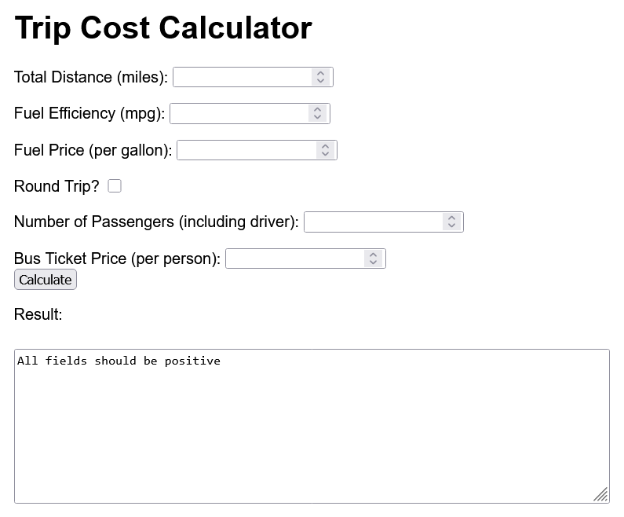

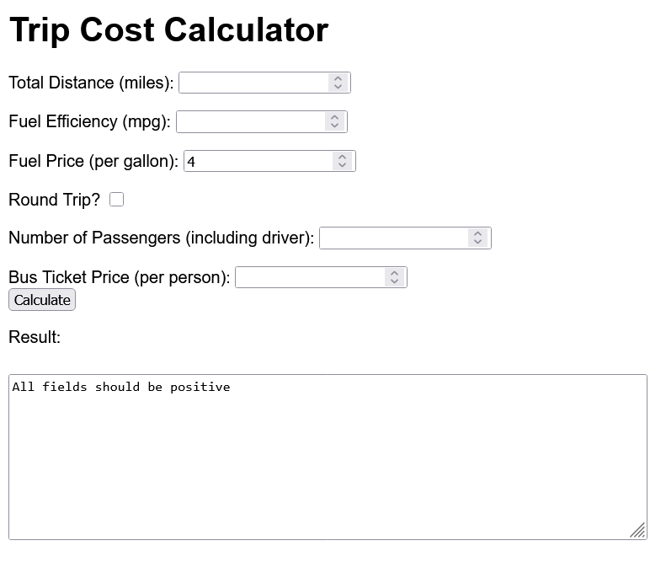
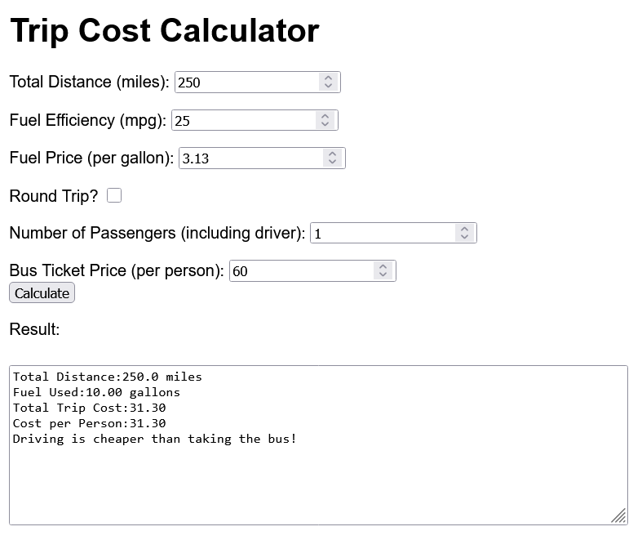

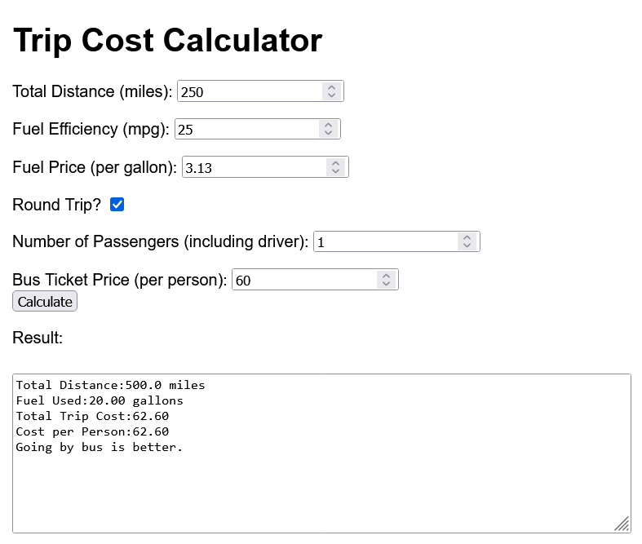
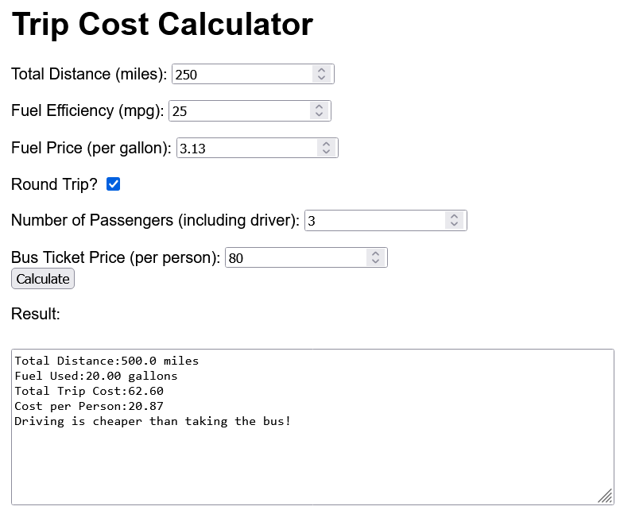

Submission rules
You need to submit a single html file. Your file name must be in the format FirstnameLastname.html. You will need to write vanilla JavaScript, which means your code will work in nearly all modern browsers. Please check your code in more than one browser.

Rubric
Code works without errors: 20 pts
Numbers are printed with 2 decimals after the dot: 20 pts
The calculations are correct: 20 pts
Code has comments: 20 pts
Input checks are working: 20 pts

If you modify the html for any reason, you will lose 20 pts.
If the file-naming conventions are not followed, you will lose 10 pts.

